Database lab 8

I, Marcello De Filippis, student number 000823174, certify that this material is my original work. No other person's work has been used without due acknowledgment and I have not made my work available to anyone else.
FIRST NORMAL FORM:
- Each cell to be single Values? Order date and Address?
- Reduce multiple values in single records
- Entries in a column are of the same type
- Rows are uniquely identified – Add a unique ID or adding more columns to make unique
- Removed calculated fields

Sales Order
Sales_order_id | Order_date | customer_id | Name | Address | Item_id | description | quantity | price | amount | Total
20115 | 12-Apr-2022 | 7802 | Gray Market Electronics | 1175 Jolly Roger Blvd.  Ancaster, ON  L9T 3Y7 | 304  452 | Sony ps 2 Clone  MS Controller Clone | 50  20 | 50  10 | 2500.00  200 | 2700.00

Sales_order_id | Order_date | customer_id | Name | Address | Item_id | description | quantity | price | amount
20115 | 12-Apr-2022 | 7802 | Gray Market Electronics | 1175 Jolly Roger Blvd.  Ancaster, ON  L9T 3Y7 | 304 | Sony ps 2 Clone | 50 | 50 | 2500.00
20115 | 12-Apr-2022 | 7802 | Gray Market Electronics | 1175 Jolly Roger Blvd.  Ancaster, ON  L9T 3Y7 | 452 | MS Controller Clone | 20 | 10 | 200

Invoice
Invoice_id | Invoice_date | Sales_order_id | Customer_id | Name | Address | Item ID | Description | Quantity | Price | Amount | Total
25154 | 19-Apr-2022 | 20115 | 7802 | Gray Market Electronics | 1175 Jolly Roger Blvd.  Ancaster, ON  L9T 3Y7 | 304 | Sony Ps 2 Clone | 10 | 50.00 | 500.00 | 500.00

Inventory Status
Item_id | Description | On_hand | Allocated | On_order | available
281 | Memory pack | 48 | 28 | 50 | 70
307 | Ps 2 stand | 12 | 5 | 10 | 17

Purchase Order
Purchase_order_id | Order_date | Vendor_id | Name | Address | Item_id | Description | Quantity | Cost | amount | total
31087 | 11-apr-2022 | 403 | Knock Off Electronics | 318 Greasy Jungle Rd.  Kuala Lampur  Malaysia | 215  219  304  307 | Ps 1 controller clone  ps 1 screen  sony ps 2 clone  ps 2 stand | 10  25  20  10 | 5.00  12.00  45.00  8.00 | 50.00  300.00  900.00  80.00 | 1330.00

Items On Order
Item_id | Description | Vendor_id | Purchase_order_id | quantity
215 | PS 1 Controller Clone | 403 | 31087 | 10
215 | PS 1 Controller Clone | 518 | 3204 | 25
219 | Ps 1 screen | 403 | 31087 | 25
275 | Rumble Pack | 188 | 30095 | 20
304 | SONY PS 2 Clone | 403 | 31087 | 20
307 | PS 2 Stand | 403 | 31087 | 10
452 | MS Controller Clone | 52 | 32354 | 25

A/P Cheque
Date | Cheque Number | Vendor_id | Name | Amount
30-Apr-2022 | 55041 | 403 | Knock Off Electronics | 22,000.00

A/P inquiry
Invoice to be paid by: | Vendor_id | Name | Vendor_invoice_id | amount
15-Apr-2022 | 403 | Knock Off Electronics | 421 | 10000.00
15-Apr-2022 | 518 | Midnight Micro | 11087 | 5000.00
15-Apr-2022 | 518 | Midnight Micro | 11342 | 3000.00
15-Apr-2022 | 644 | Copy Cat Mfg. | p-904-91 | 2000.00
15-Apr-2022 | 704 | Pirate Cove Works | 11087 | 450.00

Open Purchase Order Inquiry
Purchase_order_id | Vendor_id | Item_id | Quantity | Purchase_order_date
29932 | 403 | 215  291 | 25  50 | 15-feb-2022  25-feb-2022
29945 | 644 | 275  304 | 12  10 | 22-feb-2022  22-feb-2022

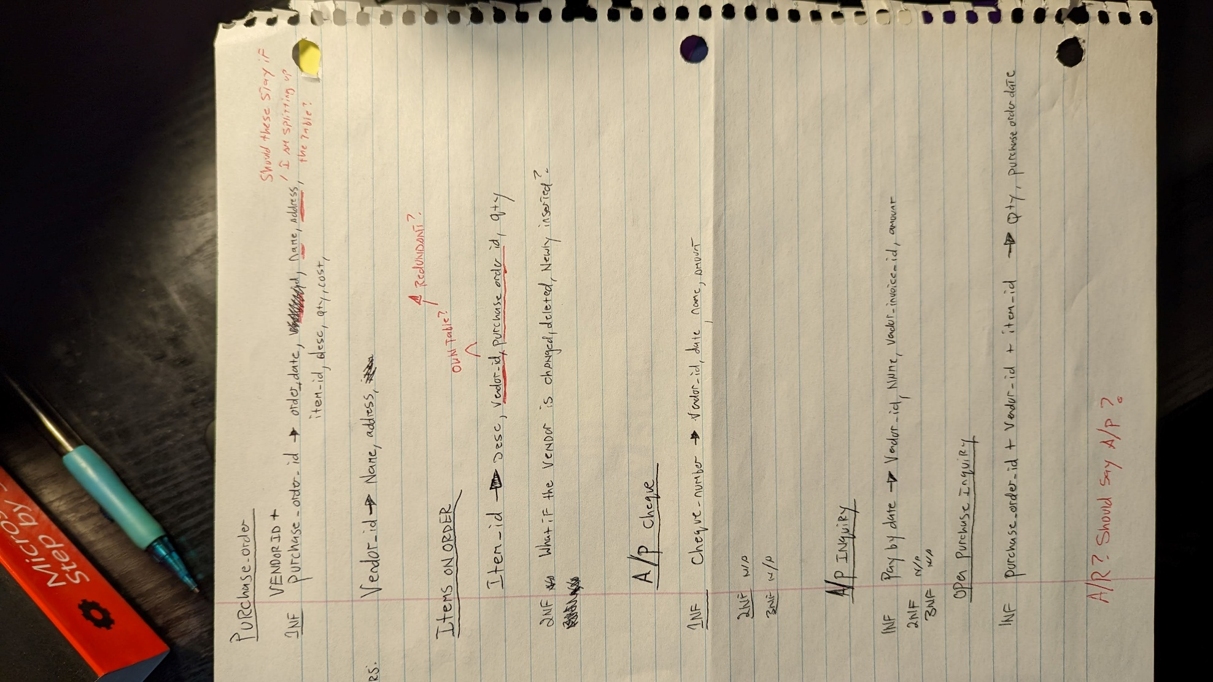
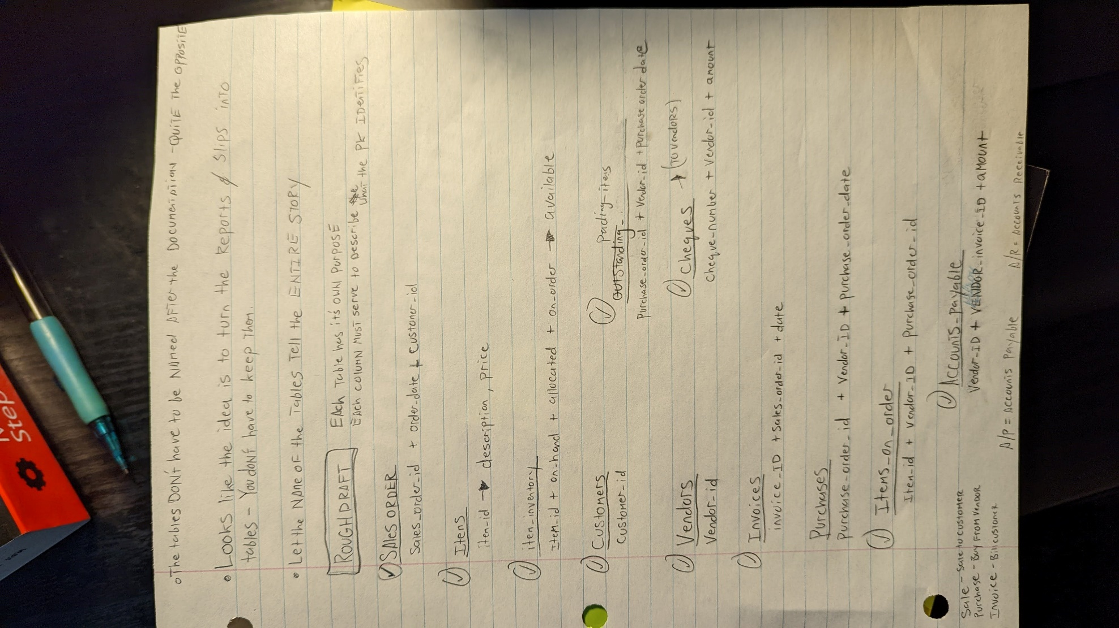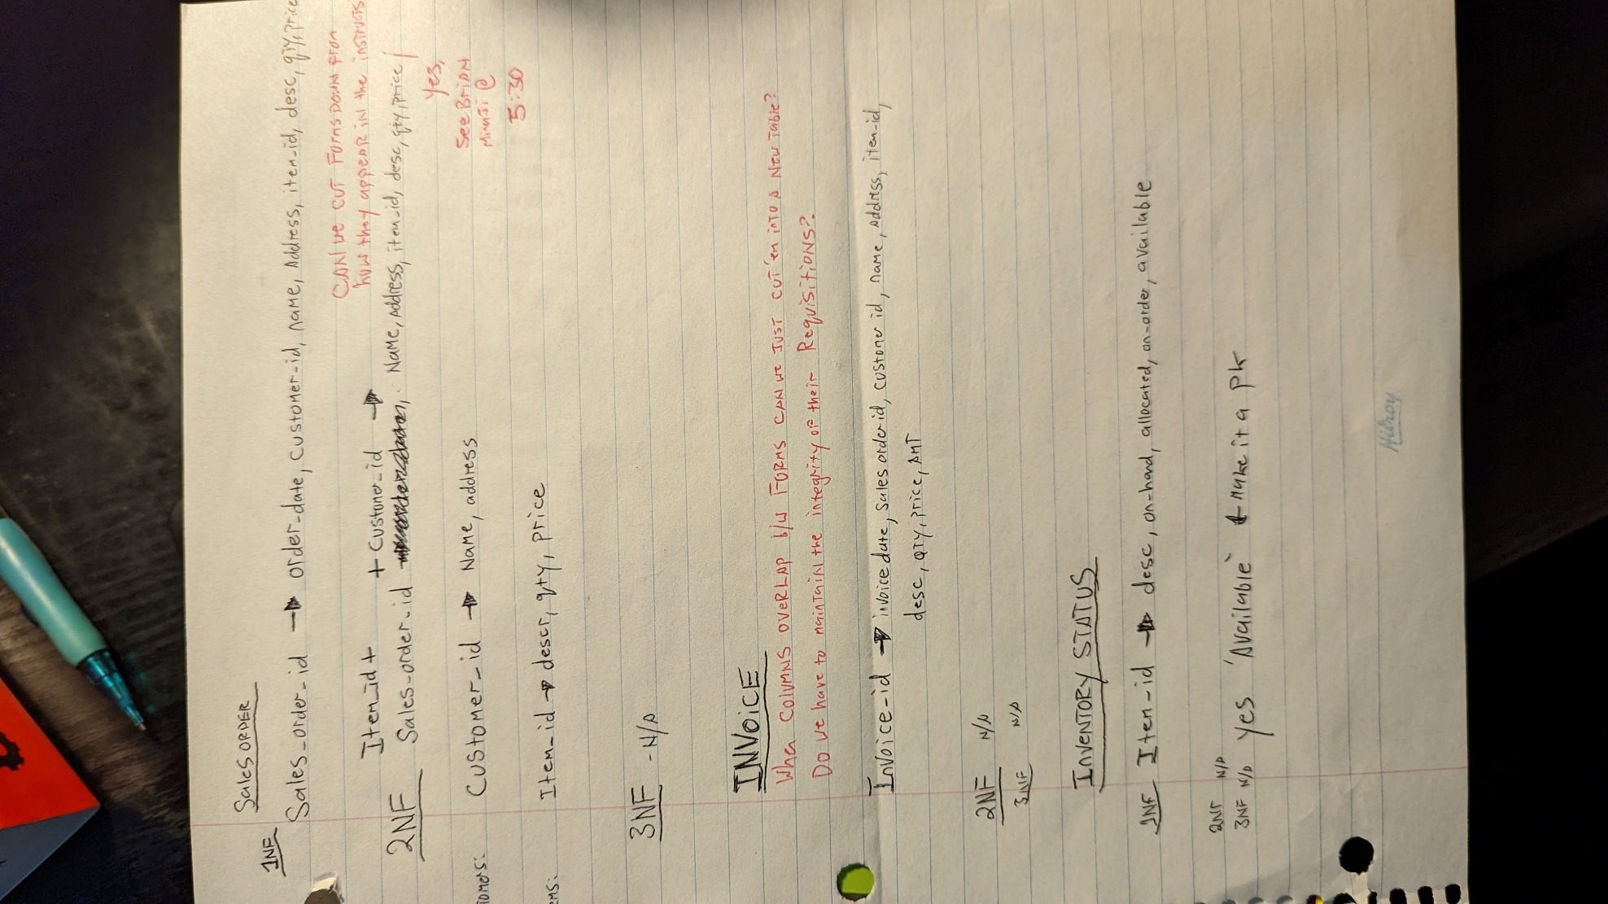
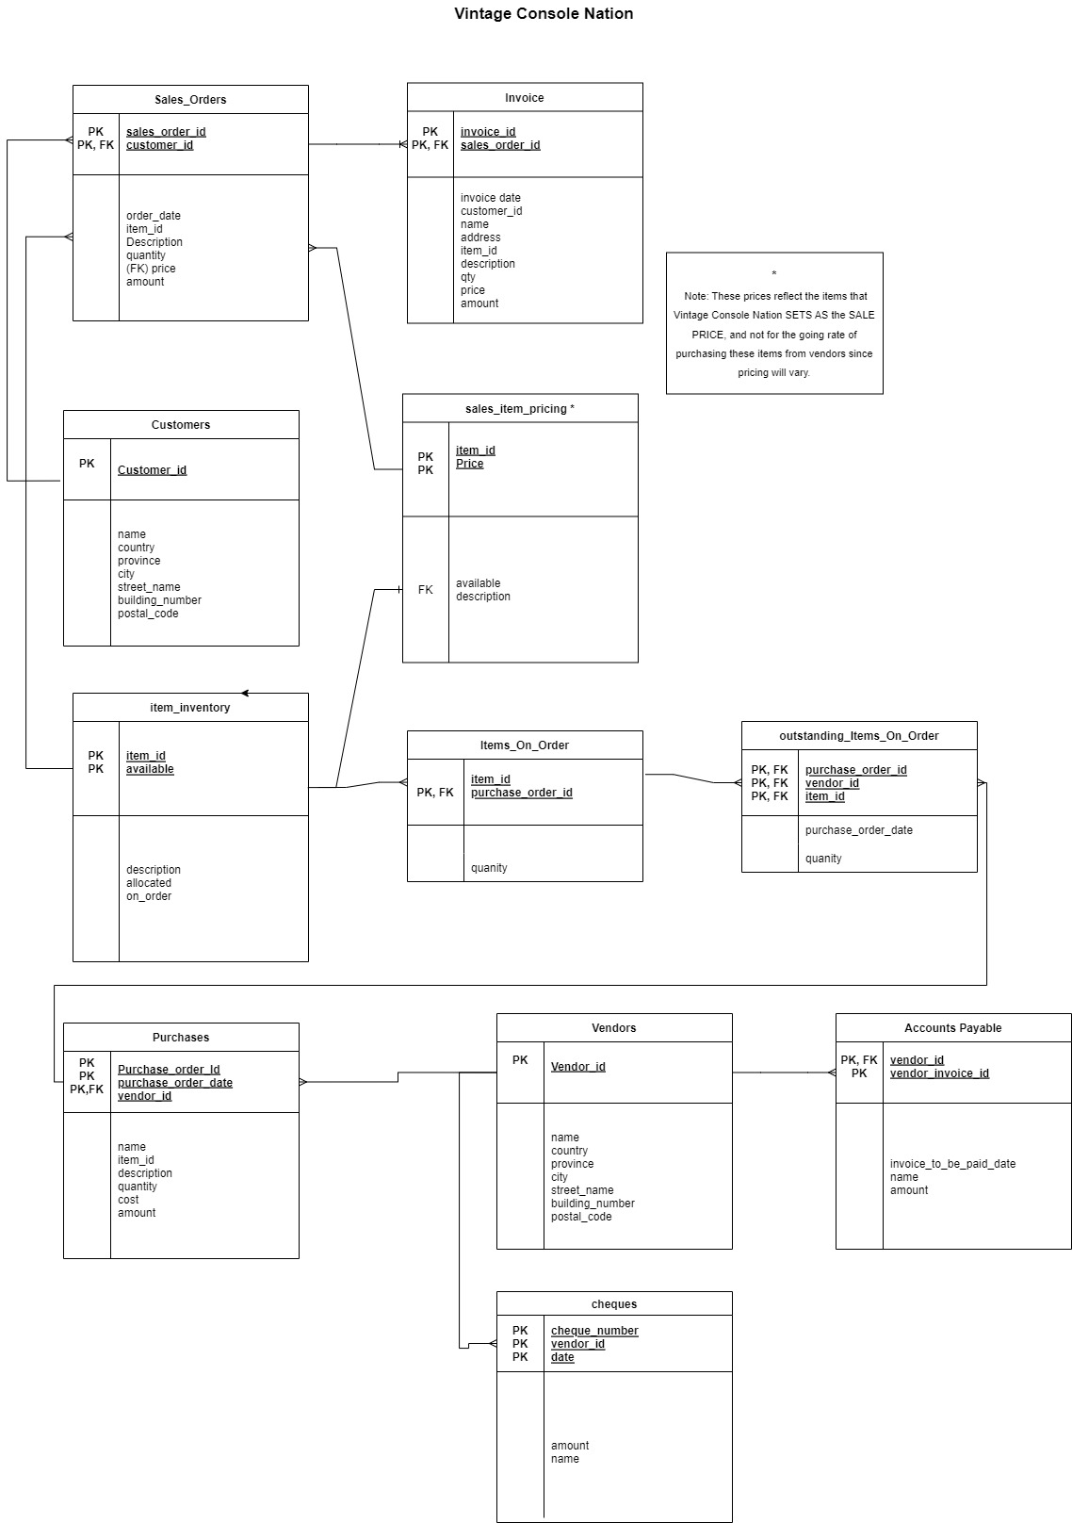ERD DIAGRAM. Saved as jpg because png caused a dark background colour?

